Software Design Principles in HRM Systems

Software design principles are a collection of guidelines, best practices, and concepts that assist developers in creating well-structured, maintainable, and efficient software systems. These principles provide a solid foundation for writing code that is easy to understand, modify, and extend, ultimately leading to improved software quality.

They are essential for object-oriented design best practices, clean code principles, and software architecture guidelines.

The key objectives of software design principles include:

* Encouraging code reusability and modularity.
* Promoting loose coupling between components or modules.
* Ensuring code readability and understandability.
* Enhancing testability, maintainability, and scalability.
* Facilitating effective collaboration among team members.

Several well-known software design principles are:

1. **SOLID**: A set of five object-oriented design principles that focus on creating maintainable and scalable code.
2. **DRY (Don't Repeat Yourself)**: A principle that emphasizes avoiding code duplication to reduce maintenance complexity and potential inconsistencies.
3. **KISS (Keep It Simple, Stupid)**: A principle that encourages simplicity in code and design, avoiding unnecessary complexity.
4. **YAGNI (You Aren't Gonna Need It)**: A principle that advises developers to focus on delivering the features that are currently needed, rather than over-engineering or anticipating future requirements.
5. **Composition Over Inheritance**: A design principle that encourages the use of composition (combining simple objects to create more complex ones) instead of inheritance (creating new classes by inheriting properties and methods from a parent class) for code reuse and extensibility.
6. **Law of Demeter (Principle of Least Knowledge)**: A principle that promotes reducing coupling between components by limiting the knowledge an object has about other objects in the system.

# SOLID Principles

**SOLID** is a set of design principles that guide developers in creating maintainable, scalable, and efficient object-oriented software systems. These principles provide a foundation for writing code that is easy to understand, modify, and extend. By adhering to **SOLID** design principles, developers can create a well-structured codebase that is less prone to bugs and easier to refactor. **SOLID** principles not only improve the overall quality of the software but also make it more adaptable to changing requirements and facilitate collaboration among team members.

**SOLID** is an acronym that represents five fundamental principles:

1. Single Responsibility Principle (SRP)
2. Open-Closed Principle (OCP)
3. Liskov Substitution Principle (LSP)
4. Interface Segregation Principle (ISP)
5. Dependency Inversion Principle (DIP)

**Single Responsibility Principle (SRP)**

**Definition**: The Single Responsibility Principle states that a class should have only one reason to change, meaning it should have just one responsibility. In other words, each class should focus on a single task or concern to make the code more maintainable and understandable.

**HRM Example:**

* **Separate classes for:**
  + EmployeeOnboarding: Handles new hire documentation.
  + PayrollProcessor: Manages salary calculations.
  + PerformanceReview: Tracks employee evaluations.

**Benefits:**

* Changes to payroll logic won’t affect onboarding.
* Clearer debugging for performance reviews.

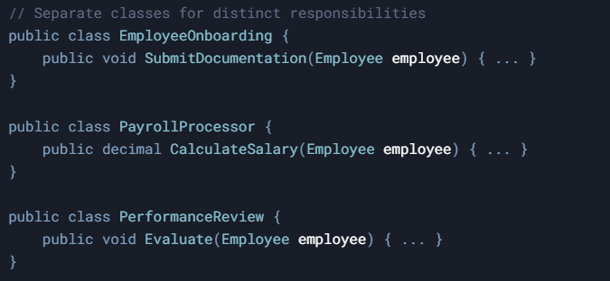By following the Single Responsibility Principle, you can design classes that are easier to understand, maintain, and modify. Remember that while this principle is a useful guideline, you should always consider the specific context of your project and strike a balance between simplicity and over-fragmentation of responsibilities.

**Open-Closed Principle (OCP)**

Definition: The Open-Closed Principle states that software entities (classes, modules, functions, etc.) should be open for extension but closed for modification. In other words, you should be able to add new functionality to a class without modifying its existing code, by extending it or using other mechanisms like composition.

**HRM Example:**

* Base class LeaveRequest with methods approve() and calculateDays().
* Extend for specific leave types without altering the base:

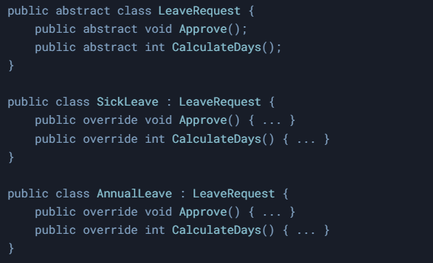

**Benefits**:

* Add new leave types (e.g., parental leave) without breaking existing code.

By following the Open-Closed Principle, you can design classes that are flexible and easy to maintain. Keep in mind that it's a guideline, not a strict rule. Sometimes, it's necessary to modify existing code to improve it or fix issues. The key is to strike a balance between keeping your code flexible and maintaining its quality.

**Liskov Substitution Principle (LSP)**

**Definition**: The Liskov Substitution Principle states that objects of a derived class should be able to replace objects of the base class without affecting the program's correctness. In other words, derived classes should adhere to the behavior and contracts defined by the base class.

**HRM Example**:

* Base class Employee with method calculateSalary().
* Subclasses FullTimeEmployee and ContractEmployee must implement calculateSalary() consistently.

**Violation**: A ContractEmployee subclass that removes calculateSalary() would break LSP.

**Benefits**:

* Ensures payroll systems work for all employee types.

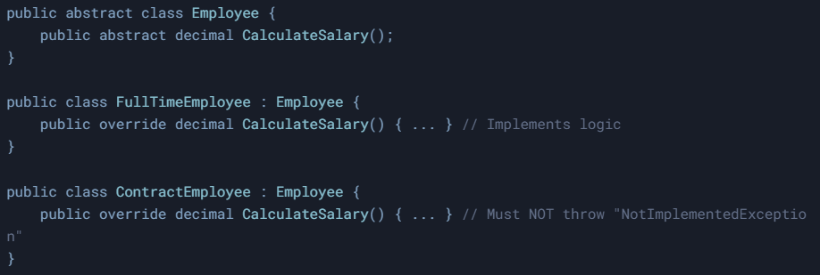

By following the Liskov Substitution Principle, you can design class hierarchies that are consistent, maintainable, and reusable. Remember that LSP is a guideline to help you create better abstractions and more reliable code, but it's essential to consider the specific context of your project to apply it effectively.

**Interface Segregation Principle (ISP)**

**Definition**: The Interface Segregation Principle states that clients should not be forced to depend on interfaces they do not use. In other words, large interfaces should be split into smaller, more specific ones so that a class implementing the interface only needs to focus on methods that are relevant to its functionality.

**HRM Example**:

* Split a bulky Employee interface into:
  + Payable: For salary processing.
  + Trainable: For skill development.
  + Promotable: For role upgrades.
* An Intern class implements Trainable but not Payable.

**Benefits**:

* Prevents interns from accidentally accessing payroll methods.

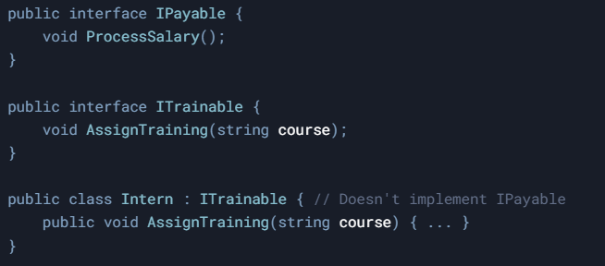

By following the Interface Segregation Principle, you can design classes and interfaces that are more focused, maintainable, and flexible. It's essential to consider the specific context of your project and strike a balance between creating focused interfaces and not over-fragmenting your interfaces.

**Dependency Inversion Principle (DIP)**

**Definition:** The Dependency Inversion Principle states that high-level modules should not depend on low-level modules; both should depend on abstractions. Furthermore, abstractions should not depend on details; details should depend on abstractions. In simple terms, this principle encourages you to depend on abstract interfaces rather than concrete implementations, promoting loose coupling and better separation of concerns.

**HRM Example**:

* High-level HRReportGenerator depends on an EmployeeRepository interface.
* Low-level classes DatabaseEmployeeRepository or CloudEmployeeRepository implement the interface.

**Benefits**:

* Switch from a local database to cloud storage without rewriting report logic.

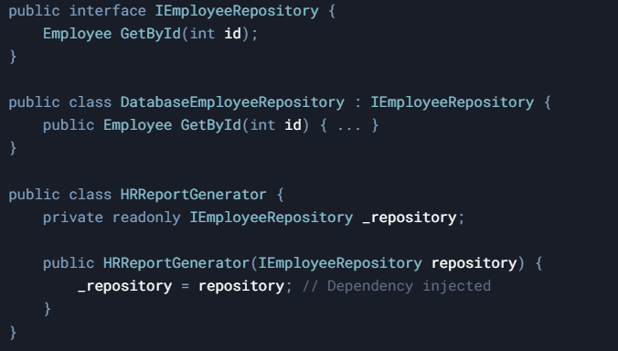

By following the Dependency Inversion Principle, you can create code that is more flexible, maintainable, and testable. Remember that this principle is a guideline to help you create better abstractions and reduce coupling, but you should always consider the specific context of your project to apply it effectively.

# DRY (Don’t Repeat Yourself)

**Example**:

* Reuse a NotificationService class to send emails/SMS for:
  + Payroll alerts.
  + Leave approvals.
  + Training reminders.  
    **Benefits**:
* Centralized changes to notification templates.

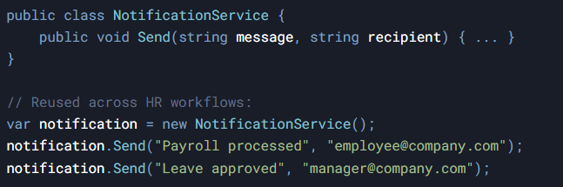

# KISS (Keep It Simple, Stupid)

**Example**:

* An EmployeeProfile class stores only essential fields:

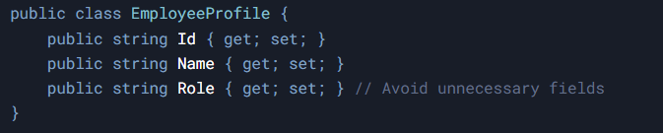

* Avoid adding unnecessary fields like favoriteColor.

**Benefits**:

* Simplifies data retrieval for HR dashboards.

# YAGNI (You Aren’t Gonna Need It)

**Example**:

* Skip building a SabbaticalLeave class unless explicitly required.  
  **Benefits**:
* Avoids overcomplicating the leave management system.

# Composition Over Inheritance

**Example**:

* Use composable roles instead of inheritance:

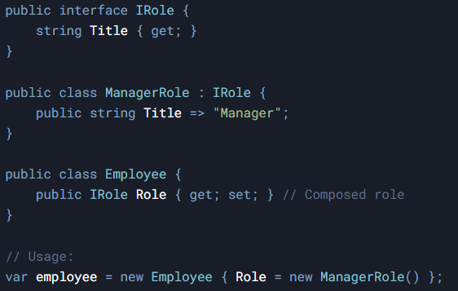

**Benefits:**

* Employees can switch roles dynamically without class hierarchy changes.

# Law of Demeter (Principle of Least Knowledge)

**Example:** 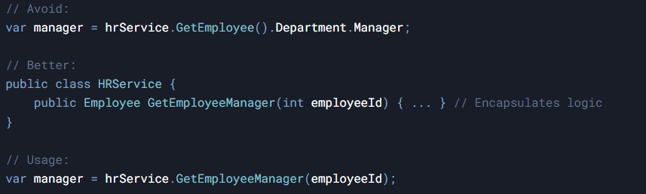

**Benefits:**

* Reduces coupling between HRService and Department classes.